- Install nginx and run nginx on port number 81.

To install nginx the command used is
Yum install nginx

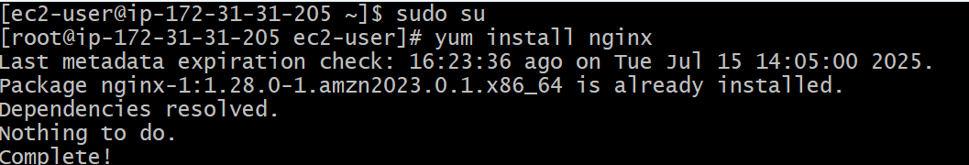

To start and check status of nginx the command as follows
Systemctl start nginx
Systemctl status nginx
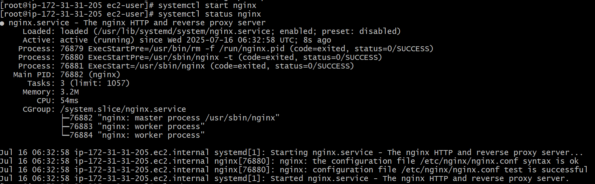

To check running services of nginx, to check running services on port number 80,
To check which service running on port number 80 --- the commands as follows

ps -ef | grep nginx
netstat -na | grep 80
lsof -i tcp:80
To find the path of nginx configurations the command is
Find / -name nginx.conf
We need to edit the nginx.conf by command “vi”

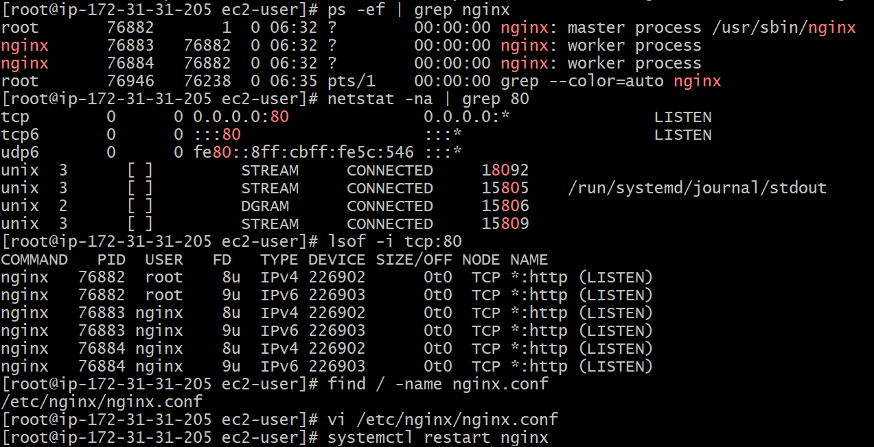

As we need to run nginx on port 81, change nginx.conf to 81 we require , save and exit

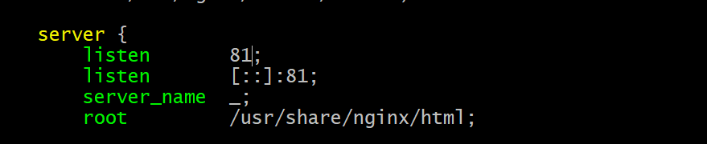

Restart the nginx and check status

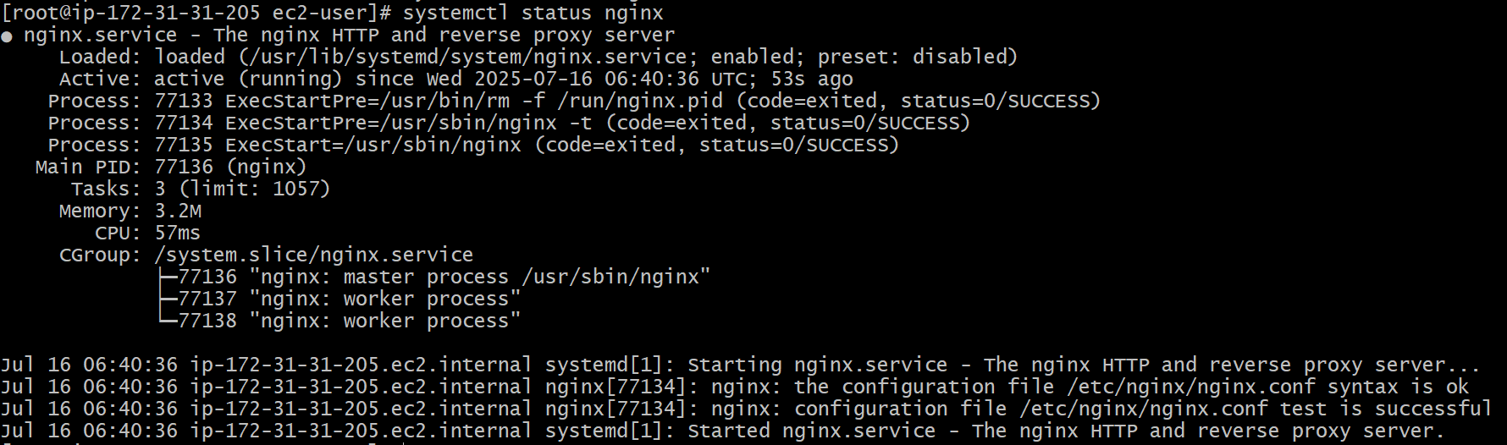

Now we can run the nginx on port number 81.

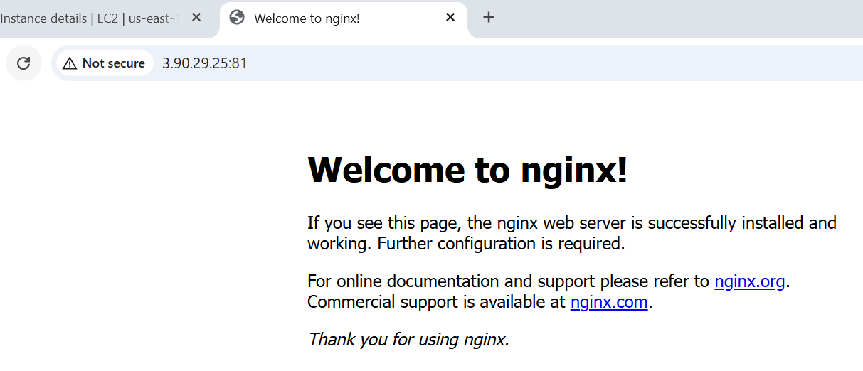

- Deploy a sample index.html file on nginx.

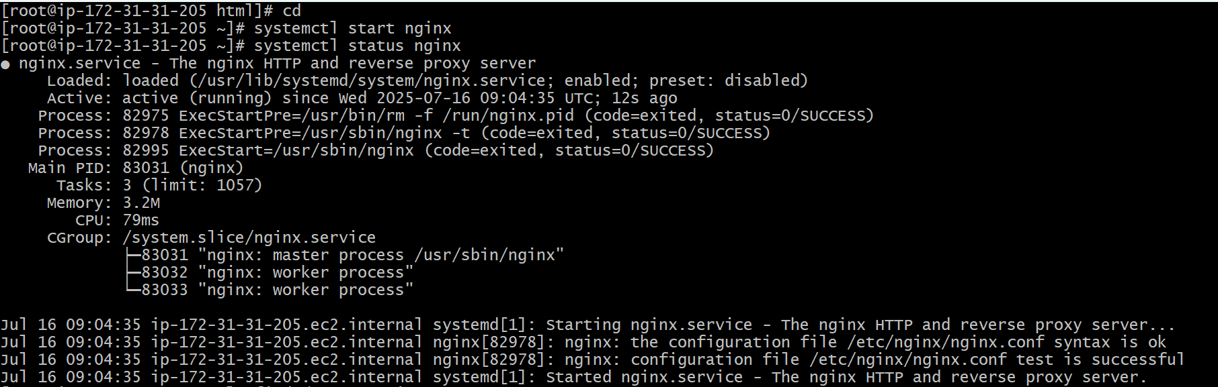

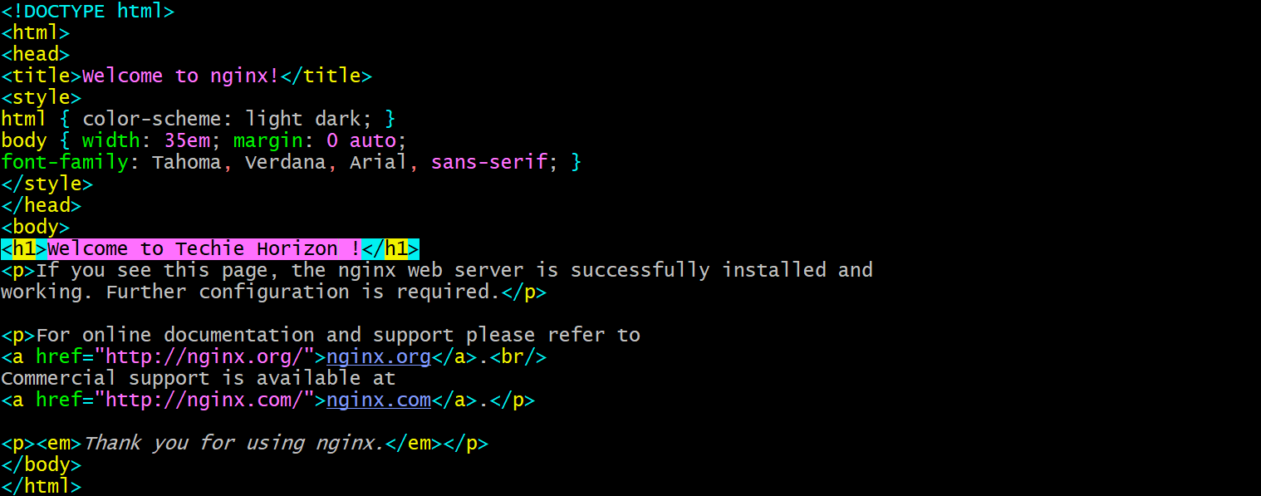

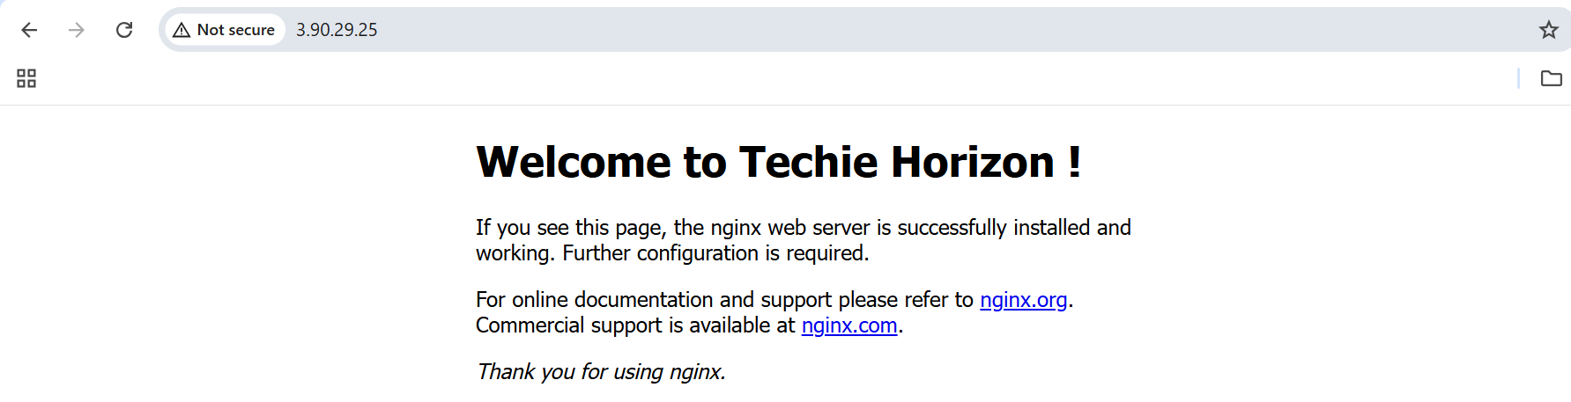

- Install Apache and run Apache on port number 82

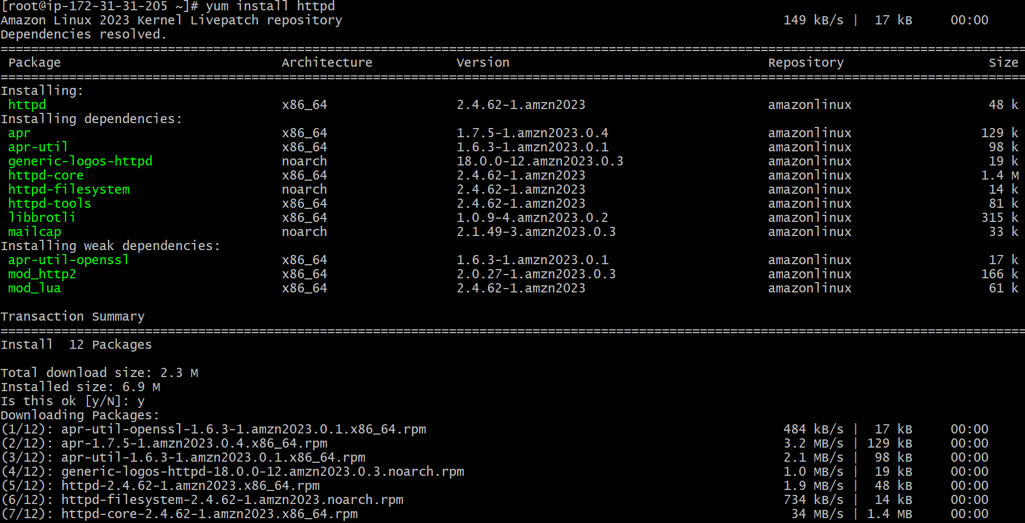

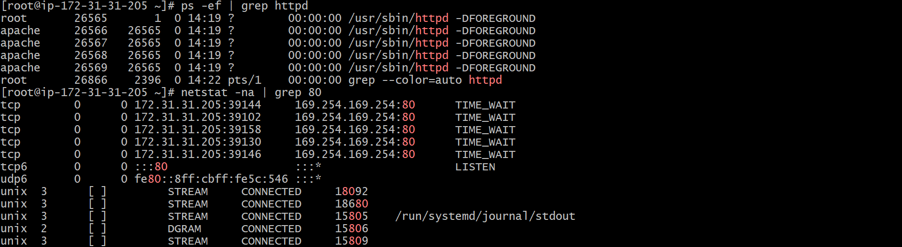

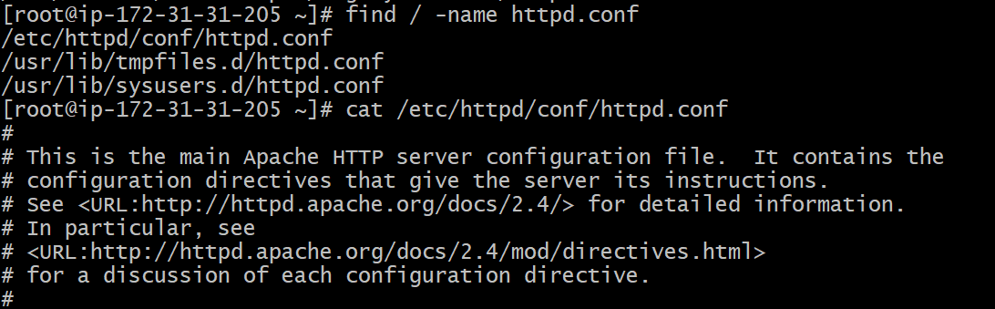

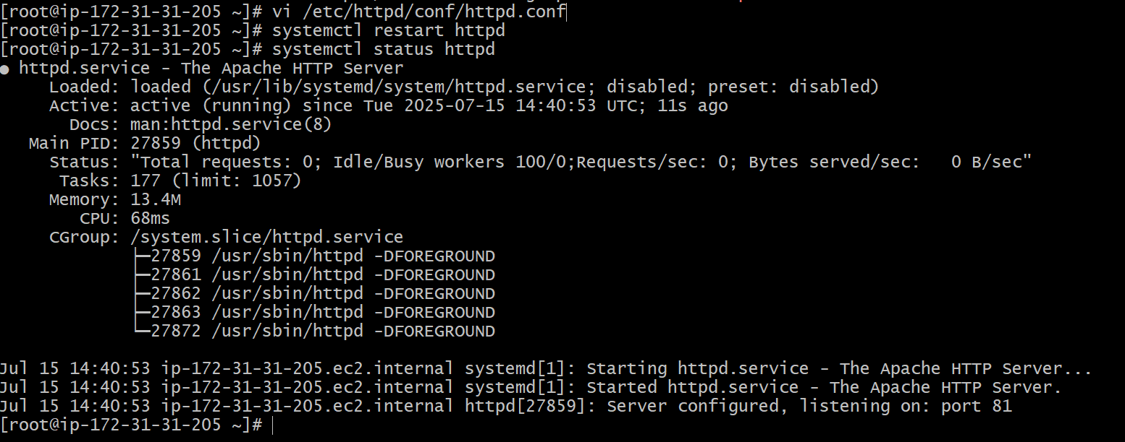

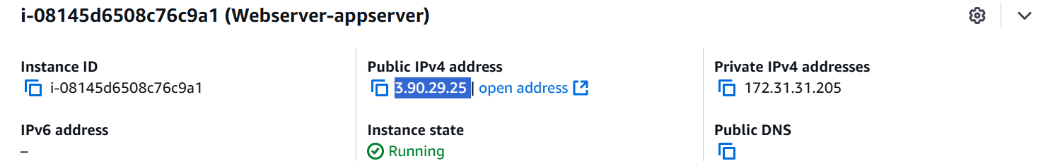

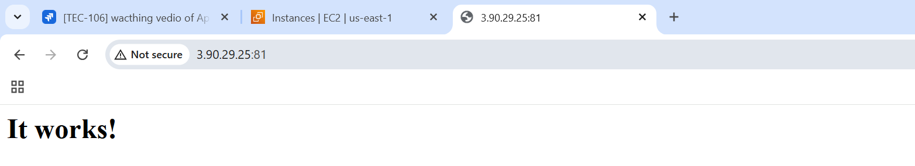

- Deploy a sample index.html file on Apache.

It is the default location of httpd

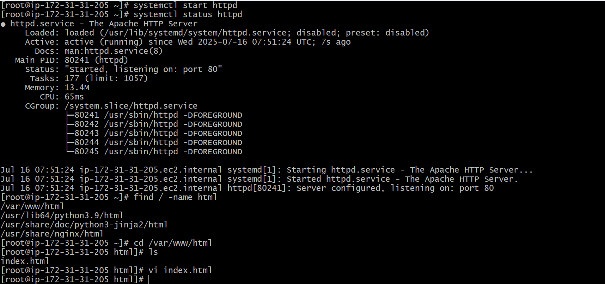



- Install Apache tomcat on port number 8082.
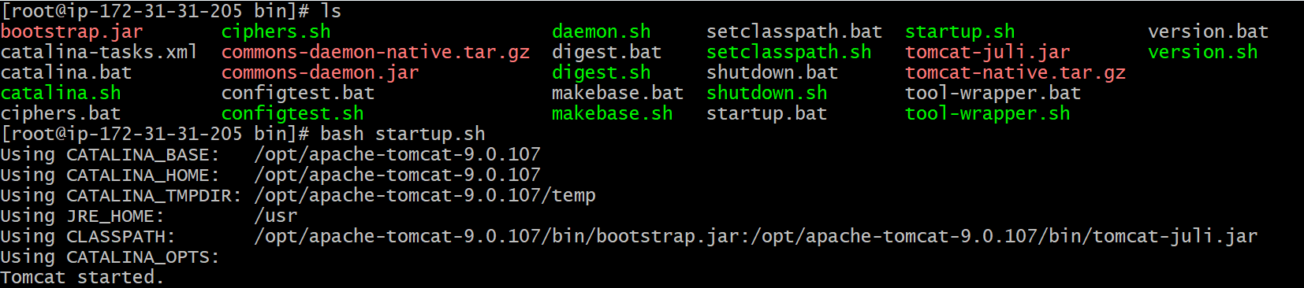

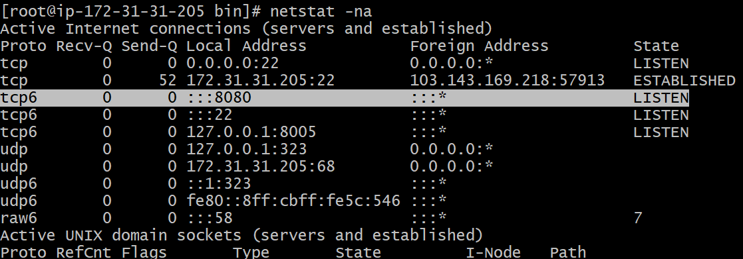

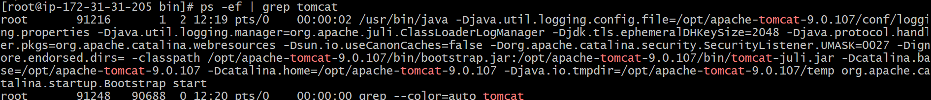

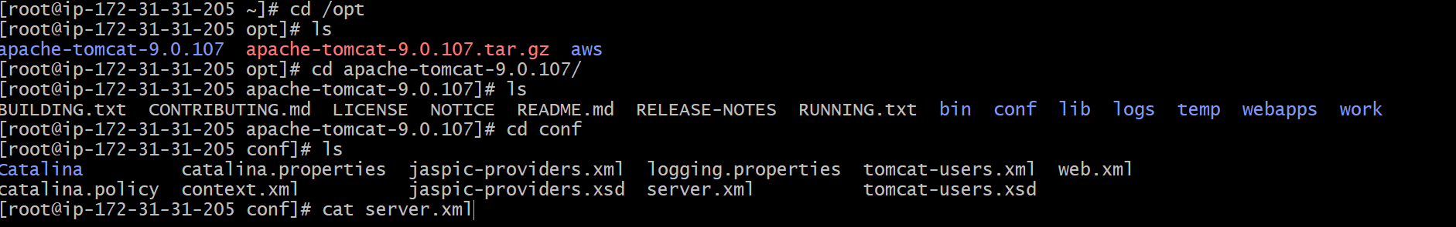

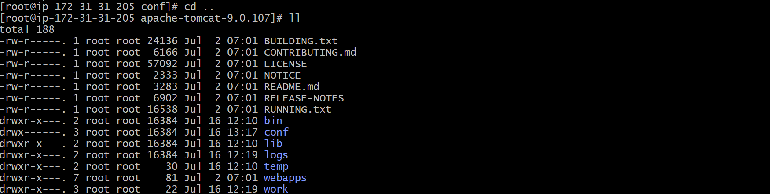

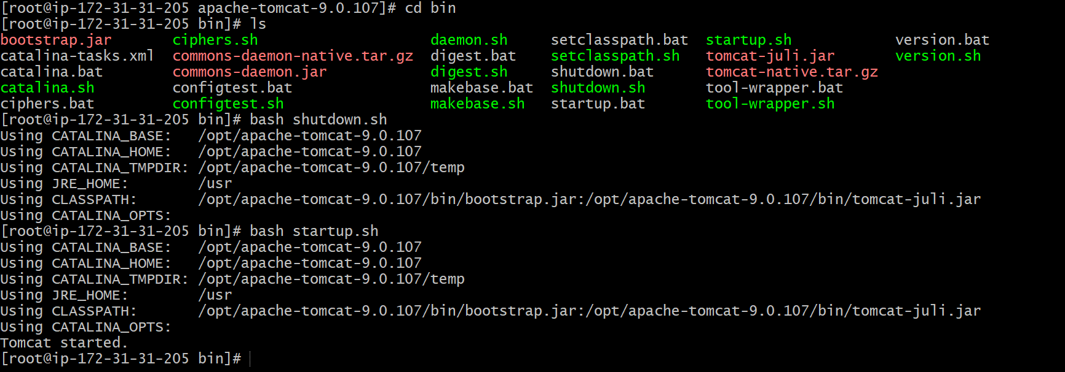

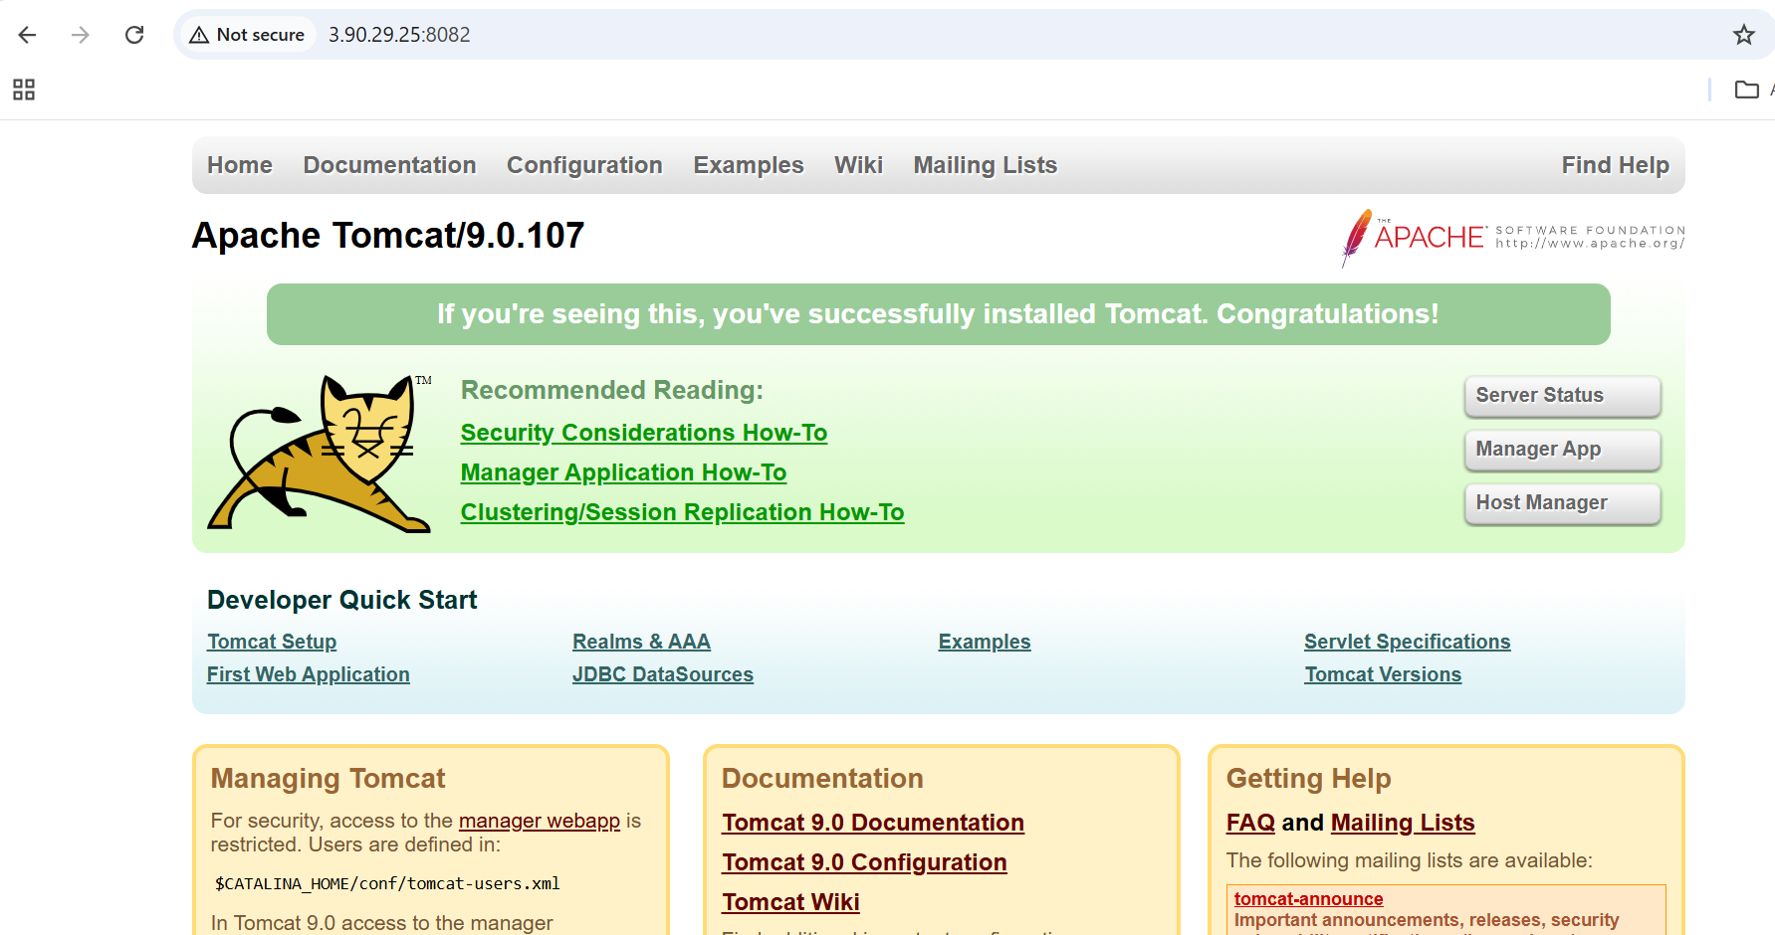

- Deploy a sample app on webapps

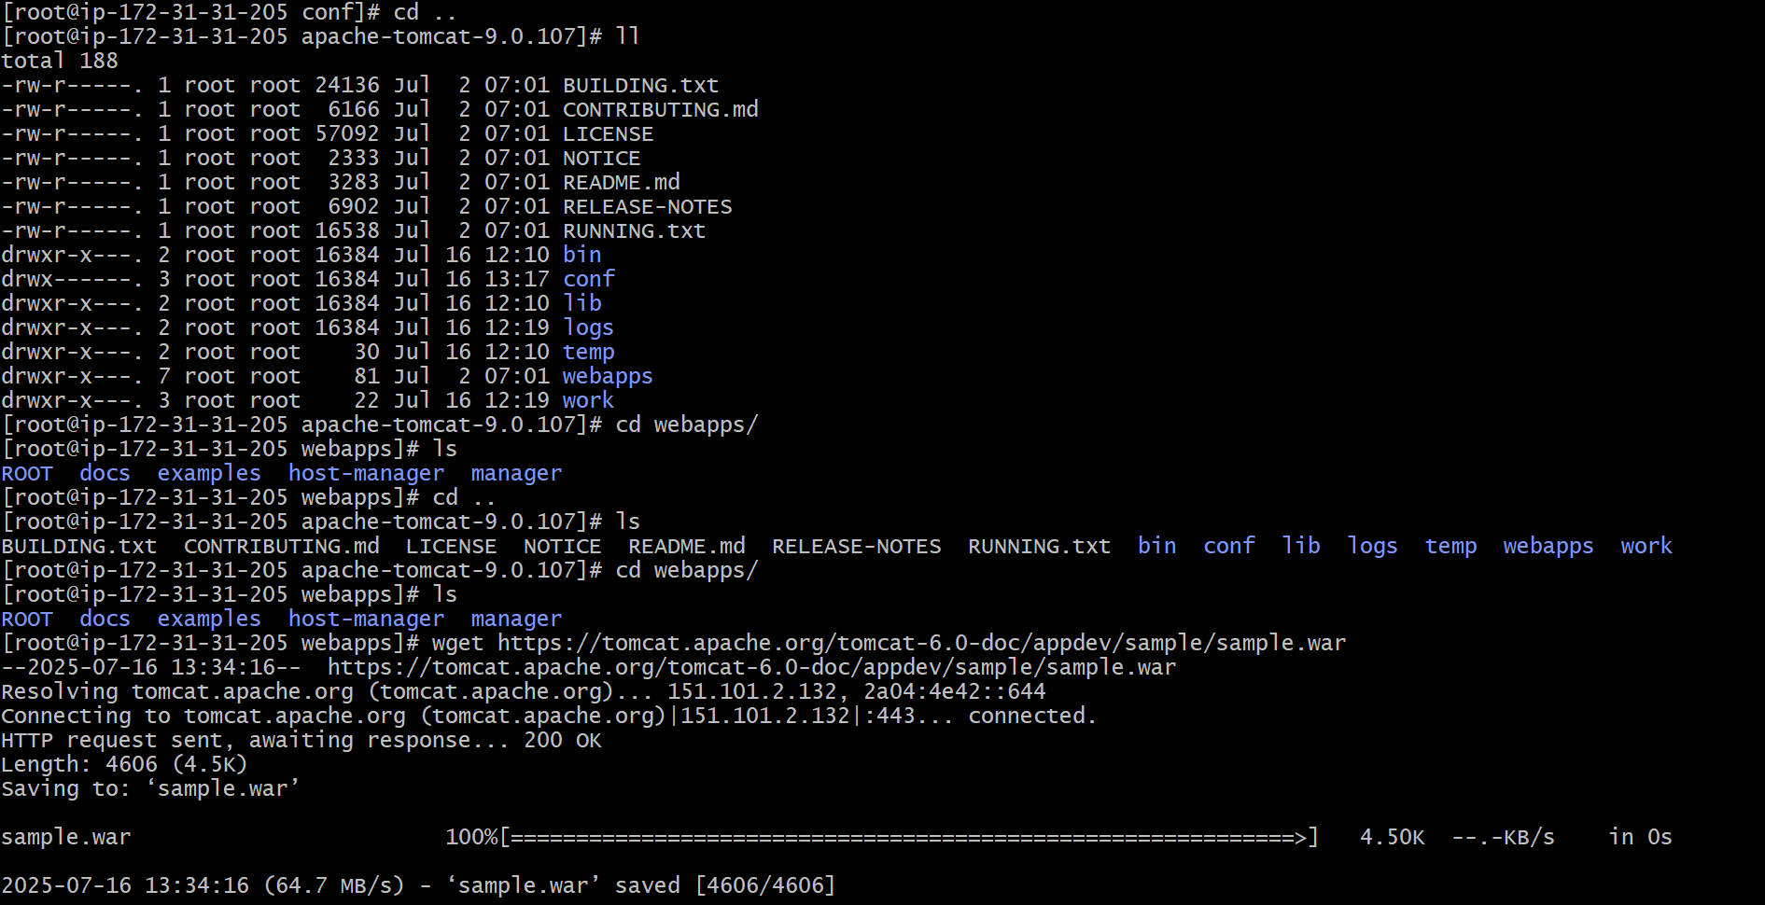

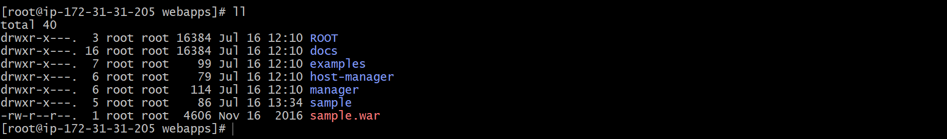

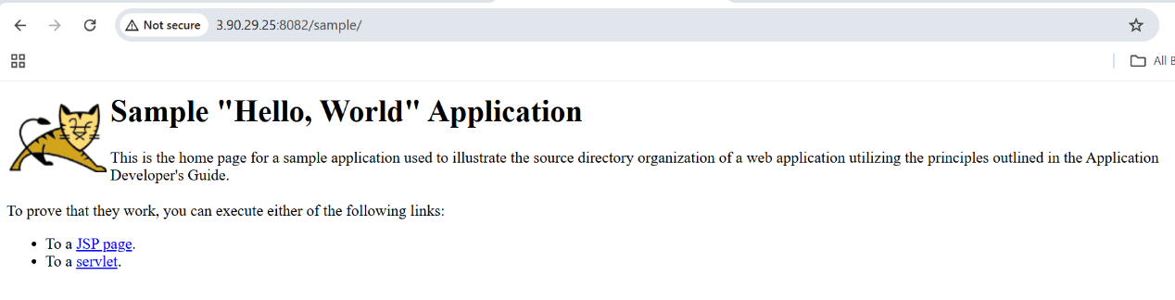

- Create a tomcat.service file for tomcat.

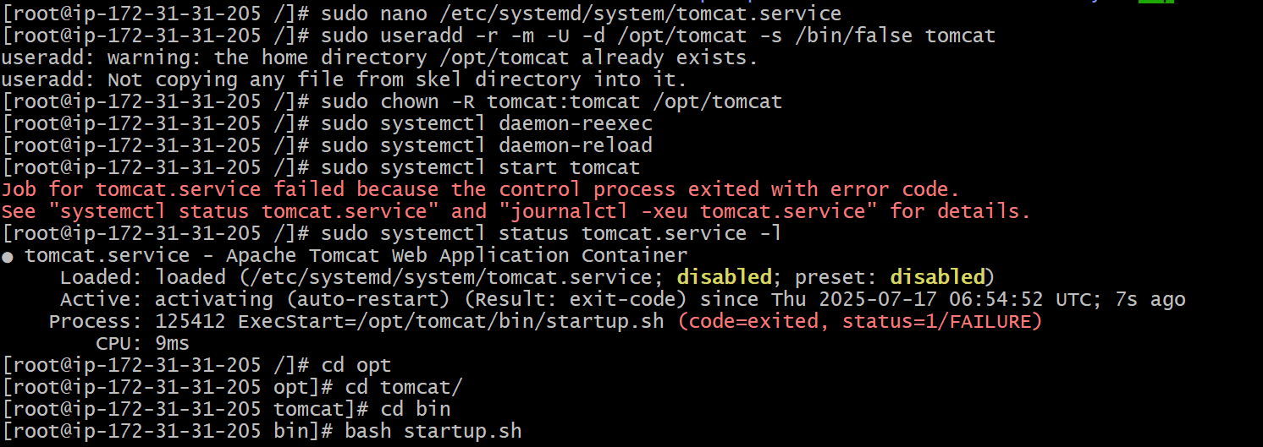

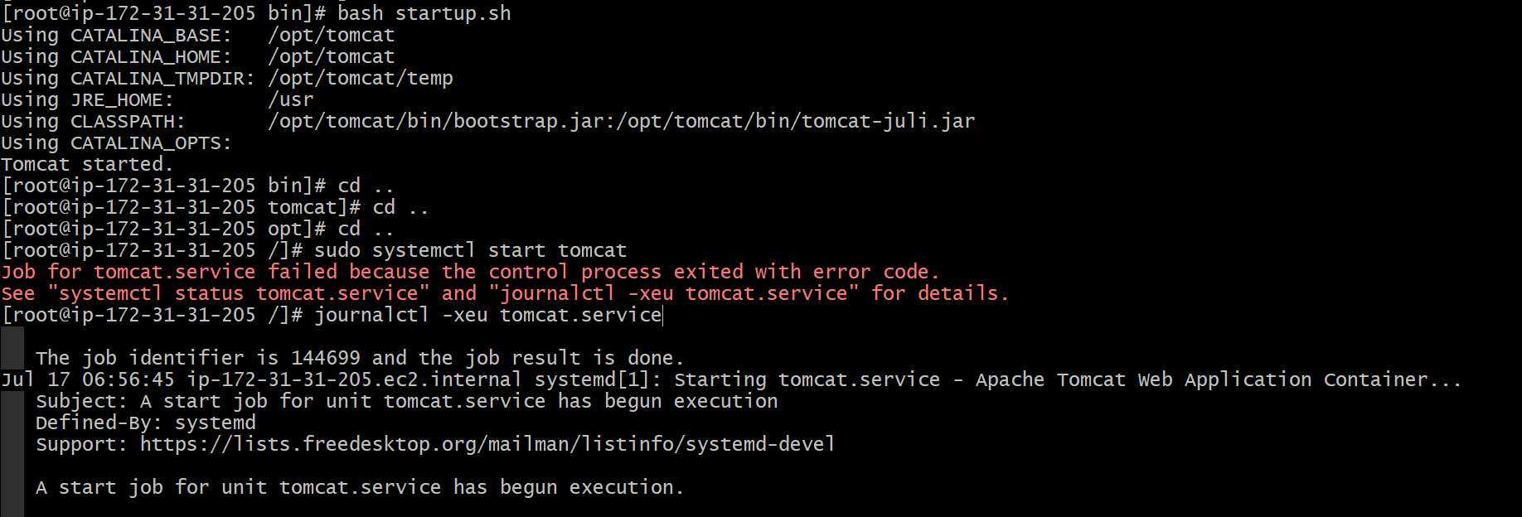
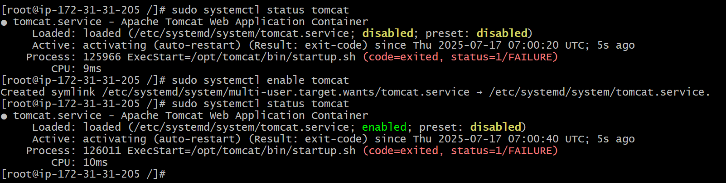

- Configure HA Proxy server.

